20.46: a) 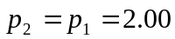 atm, 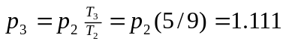atm, 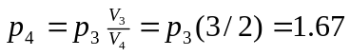atm. As a check, 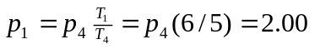atm. To summarize,
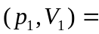(2.00 atm, 4.00 L) 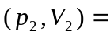(2.00 atm, 6.00 L)
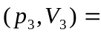(1.111 atm, 6.00 L) 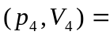(1.67 atm, 4.00 L).

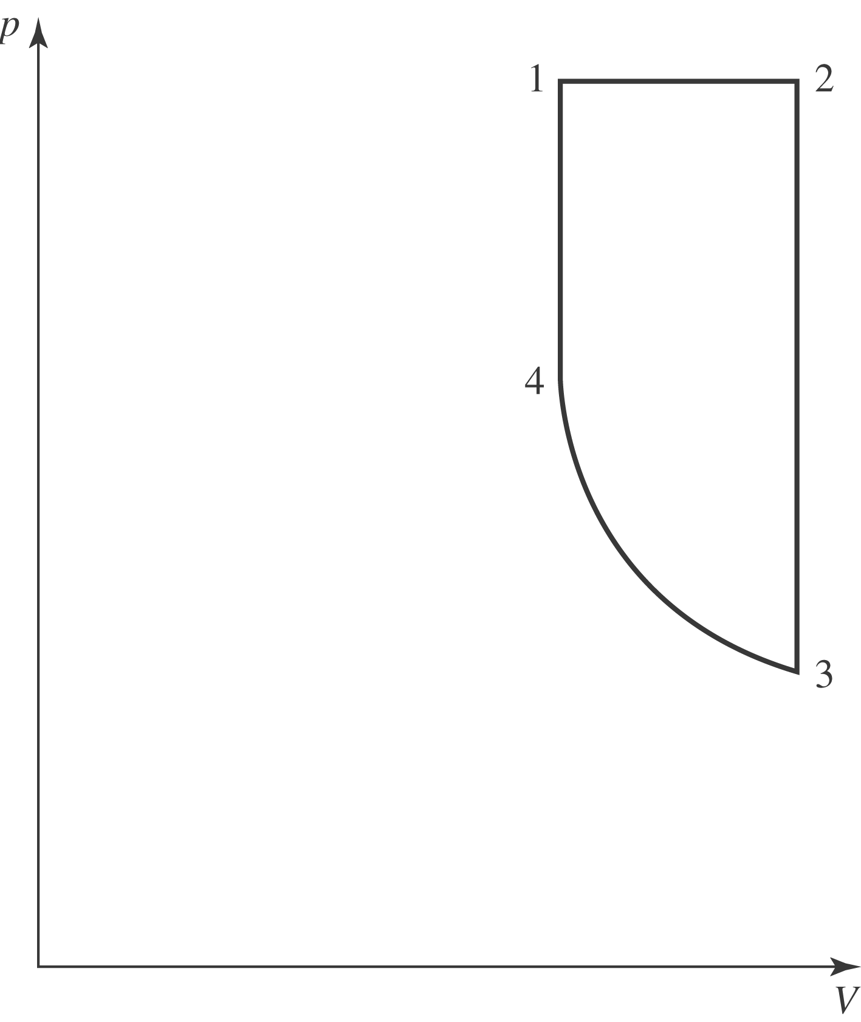

b) The number of moles of oxygen is 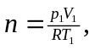and the heat capacities are those in Table (19.1). The product 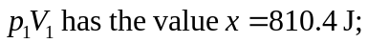 using this and the ideal gas law,
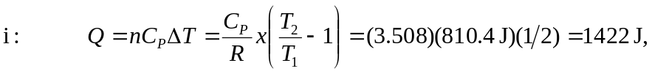
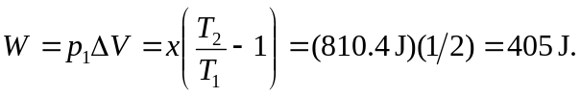
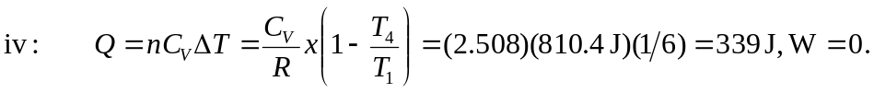

In the above, the terms are given to nearest integer number of joules to reduce roundoff error.

c) The net work done in the cycle is 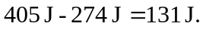

d) Heat is added in steps i and iv, and the added heat is 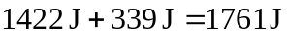 and the efficiency is 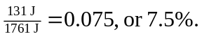 The efficiency of a Carnot-cycle engine operating between

